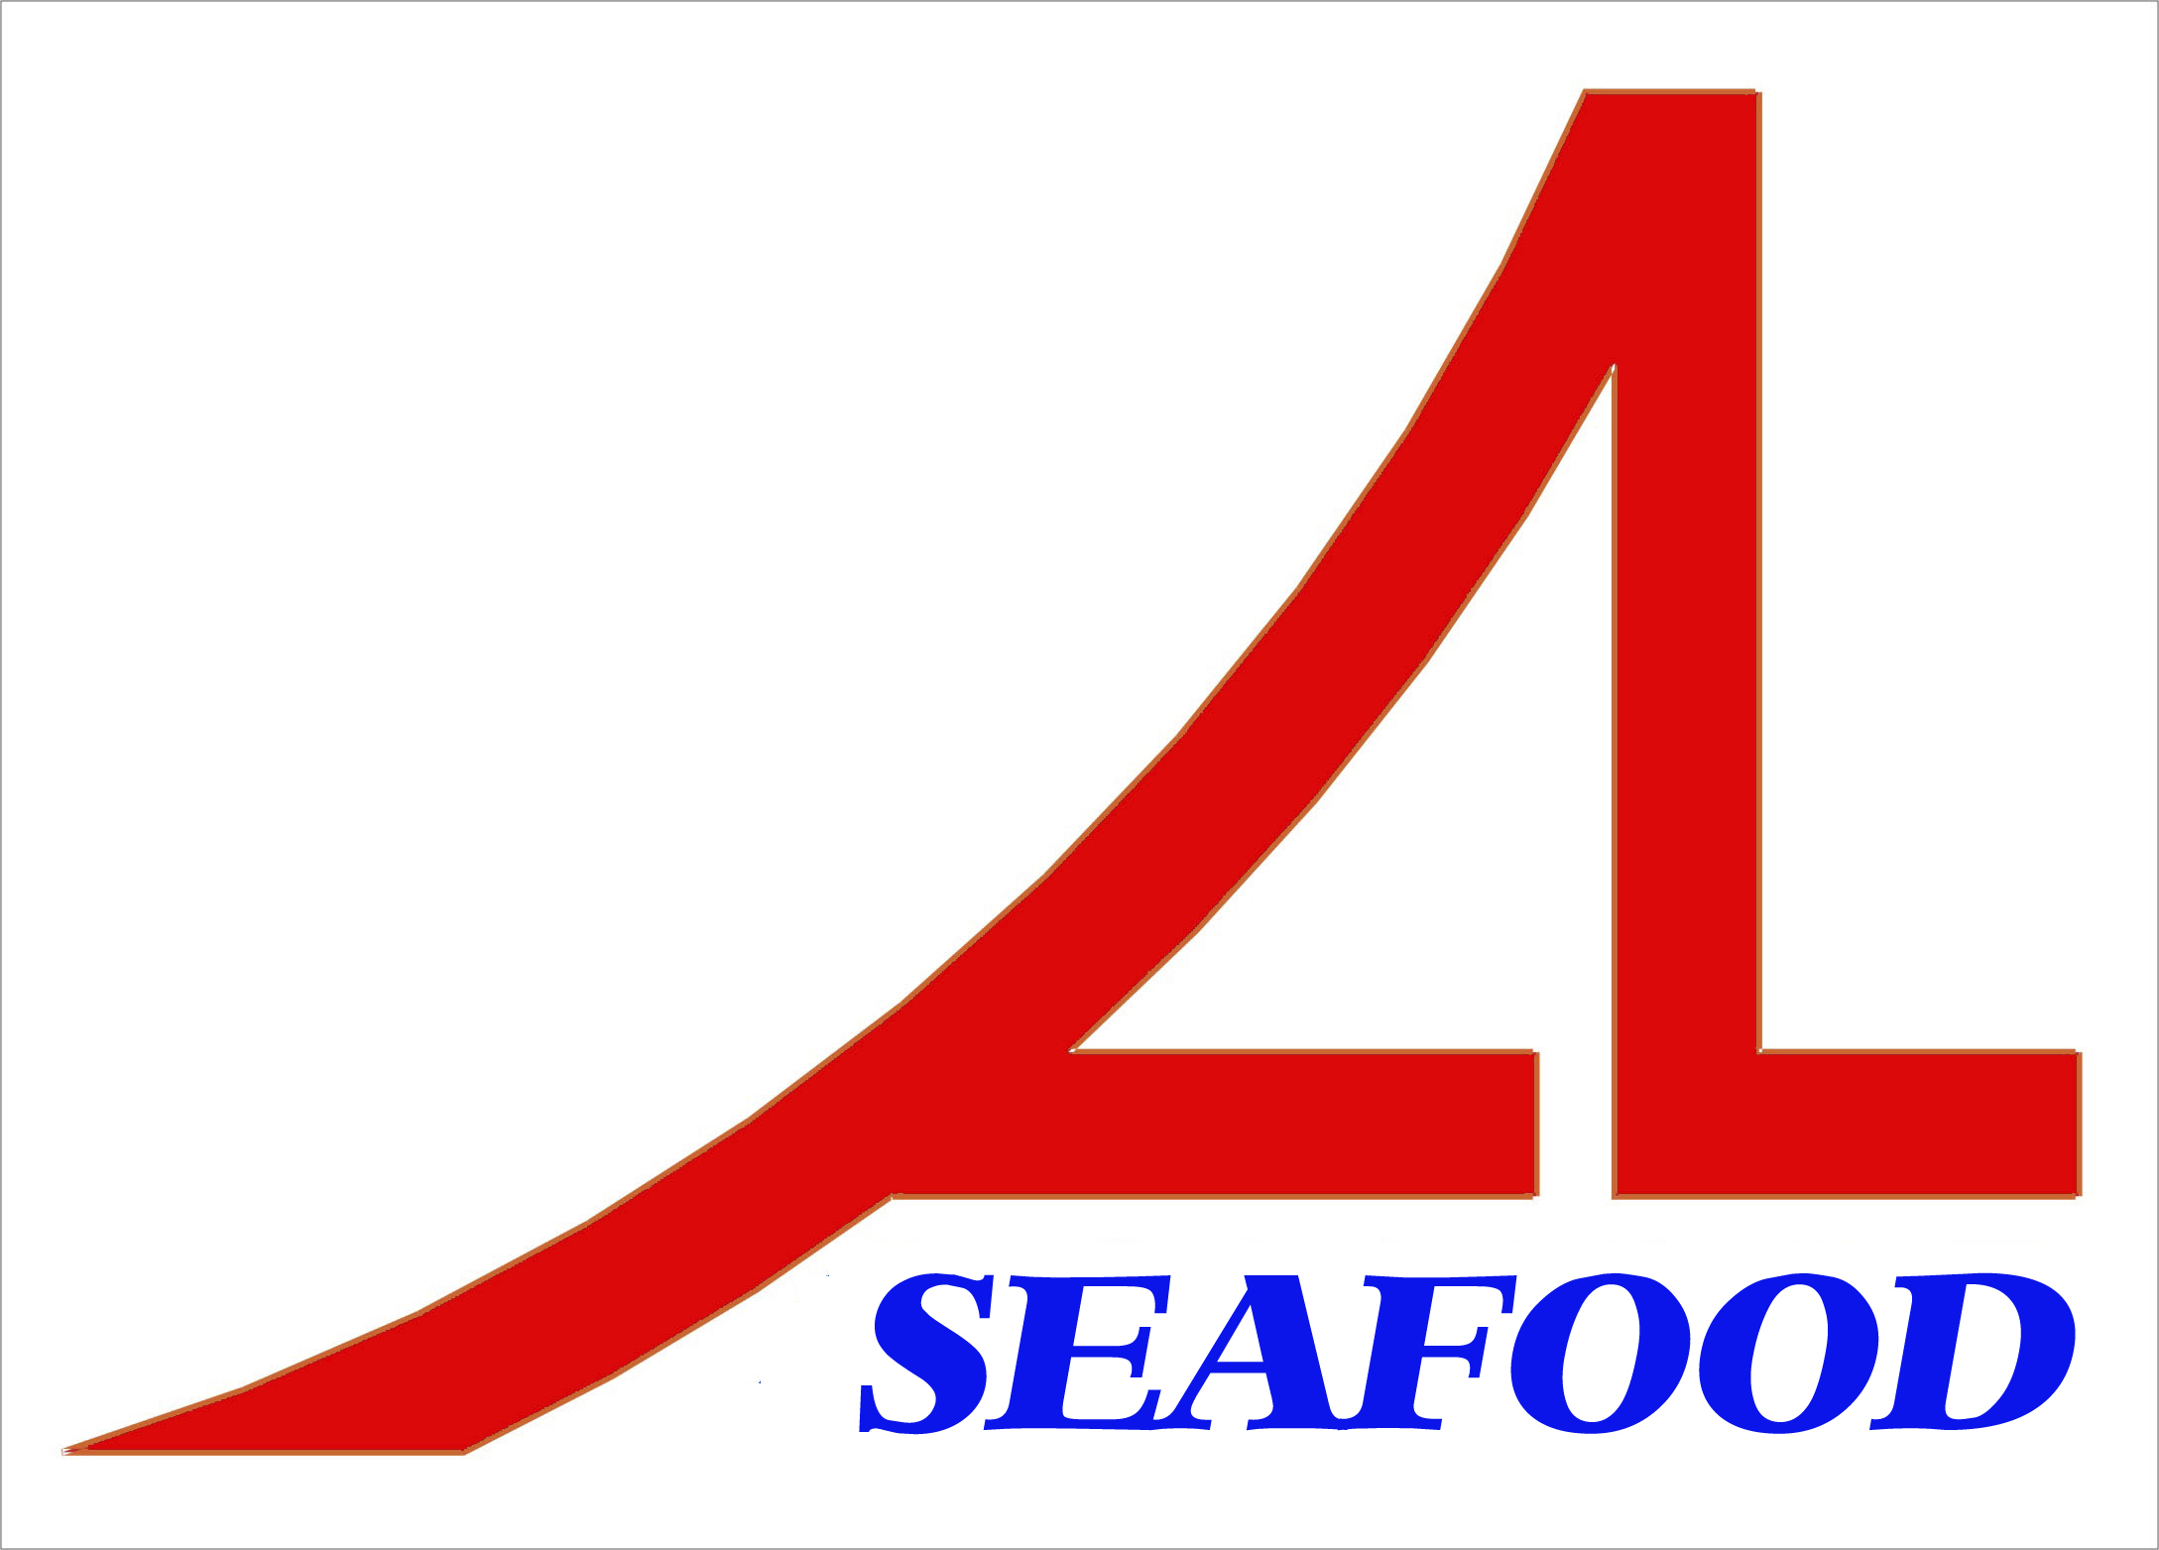AN LAC SEAFOOD CO., LTD.

Lot A14, 4A Street, Hai Son Industrial Zone, Duc Hoa District, Long An Province, Vietnam.
* Email: longan@anlacseafoods.com * Website: www.anlacseafoods.com
* Tel : 84-72-3850606 * Fax : 84-72-3850608
APPENDIX 04
No. 04 Date: June 12Th , 2015
The Seller: AN LAC SEAFOOD CO., LTD.

Add.: Lot No. A14, 4A Street, Hai Son Industrial Zone, Duc Hoa District, Long An Province, Vietnam.
Tel: 84-72-385 0606 Fax: 84-72-385 0608
Represented by: Mr Nguyễn Thiện Duy – Director

The Buyer: Markov K.A., Individual Entrepreneur
6, 24 Griboedova St., Trudovoe, Vladivostok, Russia

Base contract No KA-20140120 date Jan. 20, 2014 and the real situation, both parties have agreed signing this Appendix with the following terms and conditions:

ARTICLE 1: Commodities:

No. | DESCRITION OF GOODS | QUANTITY |  | CIF ODESSA, UKRAINE
No. | DESCRITION OF GOODS | Packages  (CTNS) | Net Weight  (KGS) | Unit Price  (USD/KG) | Amoutnt  (USD)
01 | DRIED SALTED ANCHOVY (25g x 60pcs x 6box) | 450 | 4,050.00 | 7.30 | 29,565.00
02 | DRIED SALTED YELLOW (90g x 20pcs x 6box) | 185 | 2,220.00 | 10.00 | 22,200.00
03 | DRIED SALTED YELLOW (40g x 50pcs x 6box) | 270 | 2,916.00 | 9.90 | 28,868.40
04 | DRIED SALTED YELLOW (1kg x 10pcs/box) | 300 | 3,000.00 | 8.65 | 25,950.00
TOTAL |  | 1,205 | 12,186.00 |  | 106,583.40

Article 2: Packing
- Dried Salted Anchovy:
- 25grs per piece, 60bags in a carton; 6 cartons in a bundle with Polyethylene film outside.
- 1 Kg per PA bag, 10 bags in a carton.
- Dried Yellow Stripe Trevally:
- 40grs per piece, 45bags in a carton; 6 cartons in a bundle with Polyethylene film outside.
- 90grs per piece, 20bags in a carton; 6 cartons in a bundle with Polyethylene film outside.
- 1 Kg per PA bag, 10 bags in a carton.

Article 3: Shipment – Delivery

- The goods is loading in 40 HCRF

- Latest date of shipment: Before July. 31, 2015.

- Delivery : within 21 days after receipt of first pre-payment.

- Loading Port : HoChiMinh Port, Vietnam.

- Discharging Port : Vladivostok Port, Russia.

Article 4: Payment

By 100% TTR before shipment: Pre-pay 50% - production start, and 50% - before shipment.
Bank information: EXIMBANK DISTRICT 11 BRANCH, HOCHIMINH CITY, VIETNAM.
Address: 31-33 AU CO STREET, WARD 14, DISTRICT 11, HOCHIMINH CITY, VIETNAM.
Telex: 812690 EIBVT Swift. EBVIVNVX11D
Beneficiary: AN LAC SEAFOOD CO., LTD.
Account No.: 1015 148 5100 9193
Article 5: New Consignee will be:
Markov K.A., Individual Entrepreneur
Add: 6, 24 Griboedova St., Trudovoe, Vladivostok, Russia
Article 6: General Provision:
This appendix is made in 2 copies in English that have same legal value, 1 of which for each party and have valid Dec. 31, 2014.

THE SELLER THE BUYER

